*Hindusthan College of Engineering And Technology*

**Approved by AICTE, New Delhi, Accredited with ‘A’ Grade by NAAC** (An Autonomous Institution, Affiliated to Anna University, Chennai) **Valley Campus, Pollachi Highway, Coimbatore – 641 032**

# Personal Assistance for Seniors Who Are Self-Reliant

## NALAIYA THIRAN PROJECT BASED LEARNING

**on**

## PROFESSIONAL READINESS FOR INNOVATION, EMPLOYABILITY AND ENTREPRENEURSHIP A PROJECT REPORT

JAYARAM P 19110037

AAKASH ARAVINTH G 19110001

ARUNAGIRI 19110008

MOHAMMED AFSAL 19110057

**BACHELOR OF TECHNOLOGY IN INFORMATION TECHNOLOGY HINDUSTHAN COLLEGE OF ENGINEERING AND TECHOLOGY**

**Approved by AICTE, New Delhi, Accredited with ‘A’ Grade by NAAC (An Autonomous Institution, Affiliated to Anna University, Chennai) COIMBATORE – 641 032**

**November 2022**

*Hindusthan College of Engineering And Technology*

**Approved by AICTE, New Delhi, Accredited with ‘A’ Grade by NAAC** (An Autonomous Institution, Affiliated to Anna University, Chennai) **Valley Campus, Pollachi Highway, Coimbatore – 641 032**

INTERNAL MENTOR

Mr. C.D PREM KUMAR M.Tech.,

### Assistant Professor Department of Information Technology

**Hindusthan College of Engineering and Technology, Coimbatore-641 032**

INDUSTRY MENTOR

**Kumar Juluri**

**Project Report Format**

1. **INTRODUCTION** 
   1. Project Overview
   2. Purpose
2. **LITERATURE SURVEY**
   1. Existing problem
   2. References
   3. Problem Statement Definition
3. **IDEATION & PROPOSED SOLUTION**
   1. Empathy Map Canvas
   2. Ideation & Brainstorming
   3. Proposed Solution
   4. Problem Solution fit
4. **REQUIREMENT ANALYSIS**
   1. Functional requirement
   2. Non-Functional requirements
5. **PROJECT DESIGN** 
   1. Data Flow Diagrams
   2. Solution & Technical Architecture
   3. User Stories
6. **PROJECT PLANNING & SCHEDULING** 
   1. Sprint Planning & Estimation
   2. Sprint Delivery Schedule
   3. Reports from JIRA
7. **CODING & SOLUTIONING (Explain the features added in the project along with code)** 
   1. Feature 1
   2. Feature 2
   3. Database Schema (if Applicable)
8. **TESTING** 
   1. Test Cases
   2. User Acceptance Testing
9. **RESULTS** 
   1. Performance Metrics
10. **ADVANTAGES & DISADVANTAGES**
11. **CONCLUSION**
12. **FUTURE SCOPE**
13. **APPENDIX** Source Code

GitHub & Project Demo Link

**CHAPTER 1**

**1.INTRODUCTION**

**1.1 Overview**

"We find that working with older adults on their own goals while making small changes to the home environment is powerful medicine," says Szanton, who launched the program in Baltimore, MD and has since seen it piloted in Michigan among lower-income older adults on Medicaid and Medicare. Her study, Preliminary Data from Community Aging in Place, Advancing Better Living for Elders, a Patient-Directed, Team-Based Intervention to Improve Physical Function and Decrease Nursing Home Utilization: The First 100 Individuals to Complete a Centers for Medicare and Medicaid Services Innovation Project, appears in The Journal of the American Geriatrics Society.

In a population of 100 low-income older adults on Medicaid and Medicare who participated in the CAPABLE study:

• 79 percent improved their self-care over the course of five months.

• The average participant improved by cutting disability in half (i.e., the number of self-care tasks that are difficult for the participant were halved).

• Participants experienced a decrease in depressive symptoms similar to that of taking an anti-depressant medicine.

The Centers for Medicare and Medicaid Services Innovation Center funds projects such as CAPABLE that have potential to affect the "triple aim," a framework for decreasing costs while improving health and quality of life

**1.2 Purpose**

In modern society, most of the time people remain busy in their daily life schedule. It is true that they give more preference to their work than taking care of their health. Several diseases like diabetes, blood pressure is nowadays very common. Maintaining daily medication become very difficult for old people. Sometimes younger is faced with the same problem. There are many people in our family who need constant help may it be our elderly people, younger or others. But it is not always possible for us to remind them of their medicine’s dosages every time. For this purpose, there needs to be some facility for us which monitoring patient and take care. Nowadays we are all used to living technology-based life. We can use this technology in a way that will be beneficial for us. Cell phones aren’t best utilized for calling but now maybe used as an ensemble of embedded sensors that together allow new packages including human services, healthcare, social networks, environmental tracking etc. Today in medical services frameworks, the usage of cell phones is turning into an expanding number of values [1]. IoT may be helpful to monitor realtime condition and IoT can be a powerful and effective paradigm to store data collected by sensors devices to the cloud. In our project, the IoT enabled device will control the overall monitoring system. And developed an android application which help patients by reminding medicine in take time and so on

# CHAPTER 2

# 2.LITERATURE SURVEY

According to World Health Organization, over 80% of the people above the age of 60 years are prescribed Medicines that are to be administered 2 – 4 times a day. With the increase in Cardio vascular diseases and Diabetes Among the peer group regular medicine administration Has become a necessity. But among this another 40-60% is having the issues related to forgetting the taking of Medicines at right time. He current common techniques used in market for the reminder includes the normal alarm with a pill box. But this does not check for overdose and wrong dosage among the patients. It only uses a clock, which on passage of a set time generates an alarm. Moreover the timely alerting for the rebilling of the pill box to user is also absent resulting often in breaks in the course of therapy. He sensing of slots of the pill box can be done by both load Sensing methodology and by Light based sensing. He advantages of the slot based sensing is that individual moment sensing is possible for detecting over dosage problems and incorrect dosage issues. He survey for various modes of sensing the slots has been performed both Analytically and practically and comparisons between the modes have been performed.

**REFERENCE:**

[1] Evgeny Stankevich, Ilya Paramonov, Ivan Timofeev,

‘Mobile Phone Sensors in Health Applications’.

[2] Slagle, J.M., Gordon, J.S., Harris, C.E., Davison, C.L.,

Culpepper, D.K.,Scott P. and Johnson, K.B., (2011)

“MyMediHealth– Designing a next generation system for

child-centered medication Management”, Journal of

Biomedical Informatics, Vol. 43, No. 5.

[3] Zao, J.K., Wang, M.Y., Peihsuan, T. and Liu, J.W.S.,

(2010) ”Smart Phone Based Medicine In-take Scheduler,

Reminder and Monitor”,IEEE e-Health Networking

Applications and Services (Healthcom).

[4] Prasad, B., (2013) “Social media, health care, and social

networking”,Gastroin test Endosc. Vol. 77.

[5] S.T.-B. Hamida, E. Ben Hamida, B. Ahmed, and A. Abu-

Dayya. Towards efficient and secure in-home wearable

insomnia monitoring and diagnosis system. 13th IEEE Int.

Conf. Bioinforma. Bioeng.pp. 1–6; 2013.

[6] P. Ray.Home Health Hub Internet of Things (H 3 IoT): An

architectural framework for monitoring health of elderly

people. Sci. Eng. Manag. Res. , pp. 3–5, 2014.

[7] S. S. Al-majeed. Home Telehealth by Internet of Things

(IoT). pp.609–613; 201.

[8] S. Huang, H. Chang, Y. Jhu, and G. Chen. The Intelligent

Pill Box -Design and Implementation. pp. 235–236; 2014.

[9] C. List, O. F. Authors, D. Mogo, N. Stroia, D. Petreus, R.

Moga, and R. A. Munteanu. Work Embedded Platform for

Web-based Monitoring and Control of a Smart Home no. 53,

pp. 1–3; 2015.

[10] J. M. Parra, W. Valdez, A. Guevara, P. Cedillo and J. Ortíz-

Segarra, "Intelligent pillbox: Automatic and programmable

Assistive Technology device," 2017 13th IASTED

International Conference on Biomedical Engineering

(BioMed), Innsbruck, Austria, 2017, pp. 74-81, doi:

10.2316/P.2017.852-051.

the 5G Era”. In: Karru-pusamy P., Chen J., Shi Y. (eds)

Sustainable Communication Networksand Application.

ICSCN 2019. Lecture Notes on Data Engineering

And Communications Technologies, vol 39. Springer, Cham

[14] E. E. Abdallah and E. Fayyoumi, "Assistive Technology for

Deaf People Based on Android Platform", Procedia -

Procedia Comput. Sci., vol. 94, pp. 295-301, 2016.

[15] A. J. Al-Haider, S. M. Al-Sharshani, H. S. Al-Sheraim, N.

Subramanian, S. Al-Maadeed and M. z. Chaari, "Smart

Medicine Planner for Visually Impaired People," 2020

IEEE International Conference on Informatics, IoT, and

Enabling Technologies (ICIoT), Doha, Qatar, 2020, pp.

361-366, doi: 10.1109/ICIoT48696.2020.9089536

**2.3 Problem Statement Definition**

Patients may often fail to comply with their medication whether it was from forgetting to take the medicine, from taking medicine at the wrong time or even from taking too much medicine. Therefore, there are many systems such as reminder, alarm, and so on to remind patient. We have focus on those patients who having difficulty to take medication on time, we tried to design and to aid patients with managing their medical prescriptions, through a reminder app they will use to look at and manage their medications. The Pill Reminder will facilitate users to require the right medication on time. This system provides a real time monitoring system that allow related people to monitor the patient’s activity remotely.

# CHAPTER 3

**3.IDEATION & PROPOSED SOLUTION**

**3.1 Empathy Map canvas**

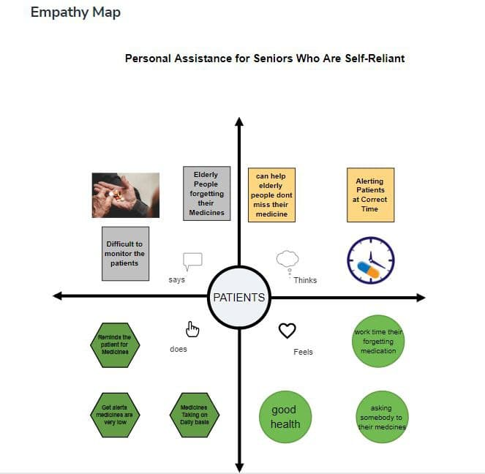

**3.2 Ideation and Brain stroming**

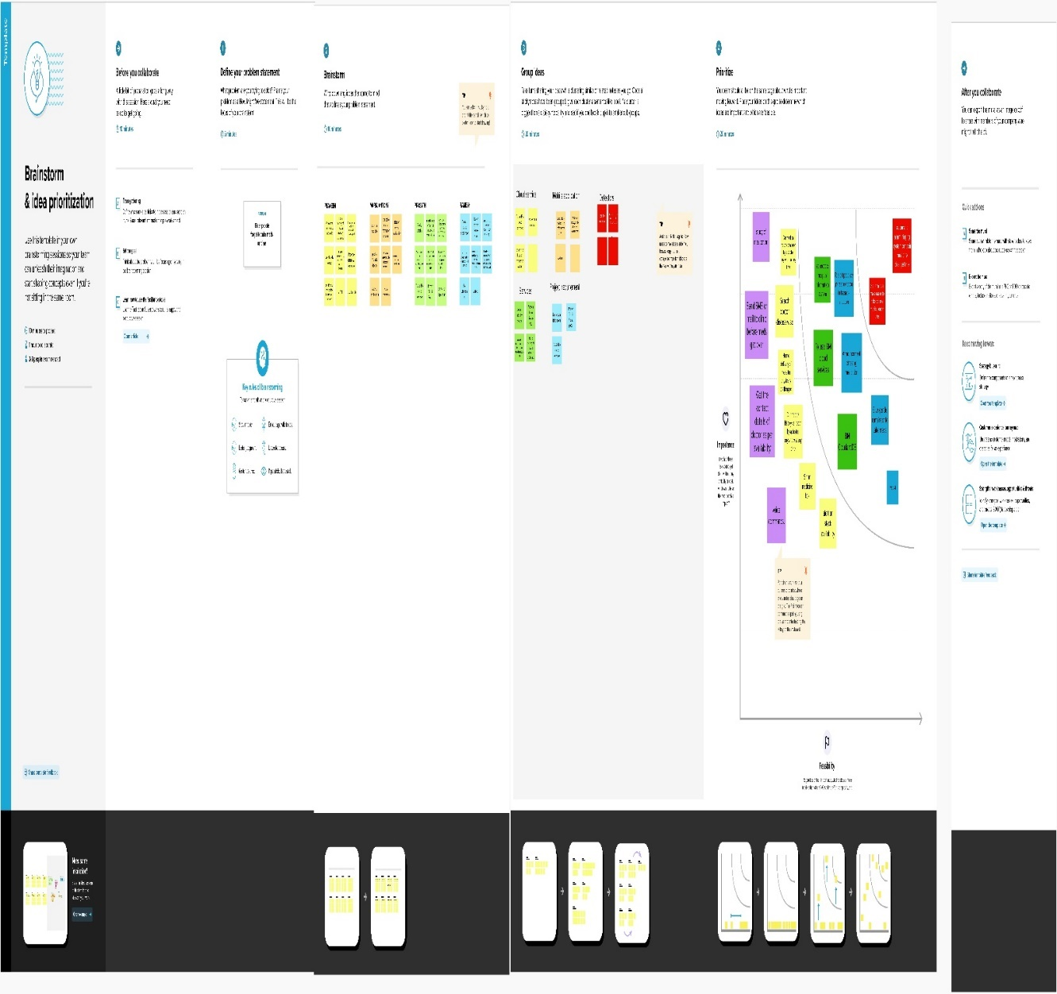

**3.3 Proposed Solution**

|  |  |  |
| --- | --- | --- |
| **S. No.** | **Parameter** | **Description** |
| 1. | Problem Statement (Problem to be solved) | ✓ To remind seniors medicine on time. |
| 2. | Idea / Solution description | ✓ By reminder application |
| 3. | Novelty / Uniqueness | ✓ Senior will get the reminder not only through the SMS but also by voice command. |
| 4. | Social Impact / Customer Satisfaction | ✓ Seniors can take the medicine on time |
| 5. | Business Model (Revenue Model) | * It is cost effective. * The model you choose depends on your target audience , business goals , and the resources you already possess |
| 6. | Scalability of the Solution | ✓ As the device is integrated with IBM cloud software , we can update the user experience without reinstalling a device by updating their medicine schedule. |

**3.4 Problem Solution Fit**

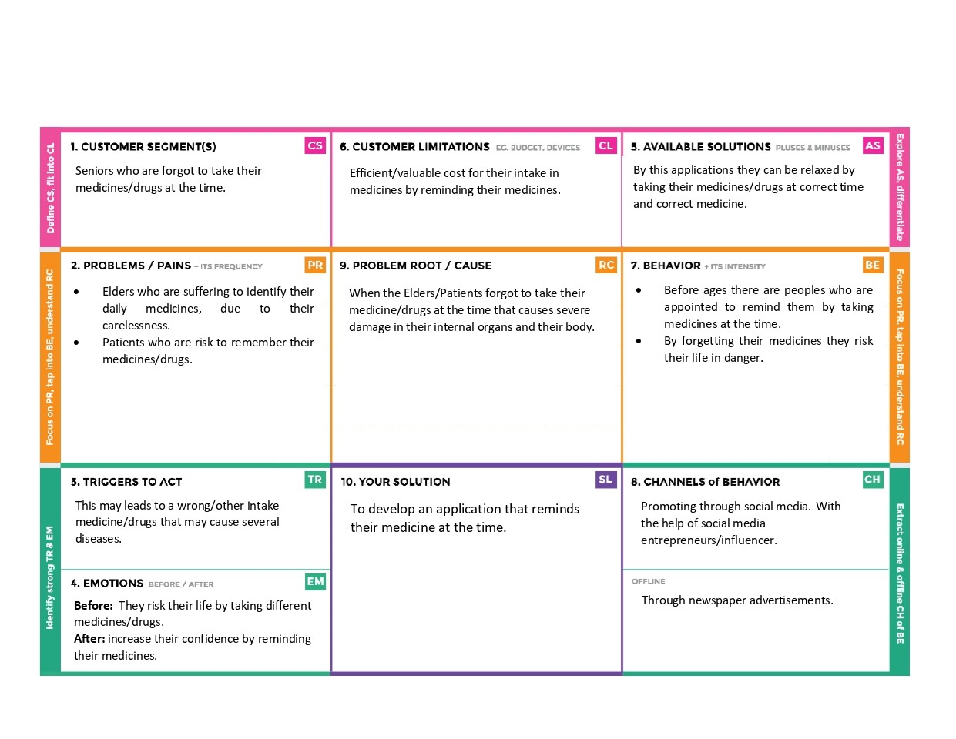

# CHAPTER 4

**4.REQUIREMENT ANALYSIS**

**4.1 Functional Requirements:**

**Functional Requirements:**

Following are the functional requirements of the proposed solution.

|  |  |  |
| --- | --- | --- |
| **FR No.** | **Functional Requirement**  **(Epic)** | **Sub Requirement (Story / Sub-Task)** |
| FR-1 | User Registration | Registration through Form  Registration through Mobile number  Registration through Gmail |
| FR-2 | User Confirmation | Confirmation via Email  Confirmation via OTP |

|  |  |  |
| --- | --- | --- |
| FR-3 | Personal Information | Gathering patient’s bio data and medicine history |
| FR-4 | Scheduling | Doctor medicine prescription  Doctor’s appointment.  Suggestion of food plan by nutritionist. |
| FR-5 | Reminding the medicine timings | Alert the person to take medicine with the correct dosage and medicine name.  Remind the doctor’s appointment.  Remind everyday’s diet plan. |
| FR-6 | Emergency alarm | Doctor and caretaker gets the alarm when the person's health is abnormal, which is indicated by heart rate fluctuations or if any fall is detected.    Caretaker gets the alarm for the person’s missed medicine. |

|  |  |  |
| --- | --- | --- |
| NFR-1 | **Usability** | Caretaker/doctor can easily schedule medicine timings through his/her dashboard.The person can acknowledge the medicine intake using a simple UI. |
| NFR-2 | **Security** | The person’s information is secured by providing access permission only to the |

|  |  |  |
| --- | --- | --- |
| **FR No.** | **Non-Functional Requirement** | **Description** |

**Non-functional Requirements:**

Following are the non-functional requirements of the proposed solution.

|  |  |  |
| --- | --- | --- |
|  |  | corresponding registered caretaker and doctor. |
| NFR-3 | **Reliability** | The application is reliable because of authentication of users and providing database updates regularly. |
| NFR-4 | **Performance** | The application uses virtual sensors, so the  performance will be high. The modularization helps in improving the performance of the application. |
| NFR-5 | **Availability** | The services provided are available to the registered users. |

|  |  |  |
| --- | --- | --- |
| NFR-6 | **Scalability** | As we are using IBM cloud, our application supports many users at the same time.Hence, it is scalable. |

# CHAPTER 5

**5. PROJECT DESIGN**

**5.1 Data flow diagrams**

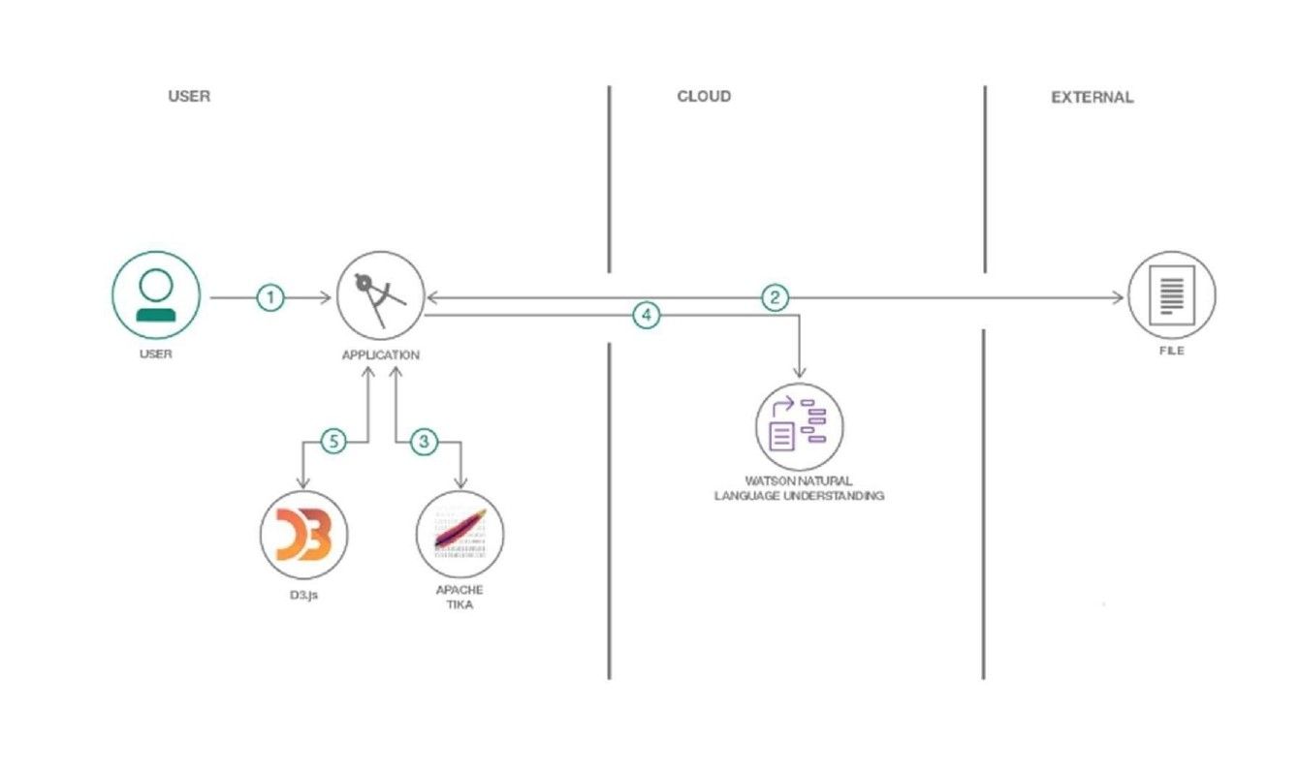

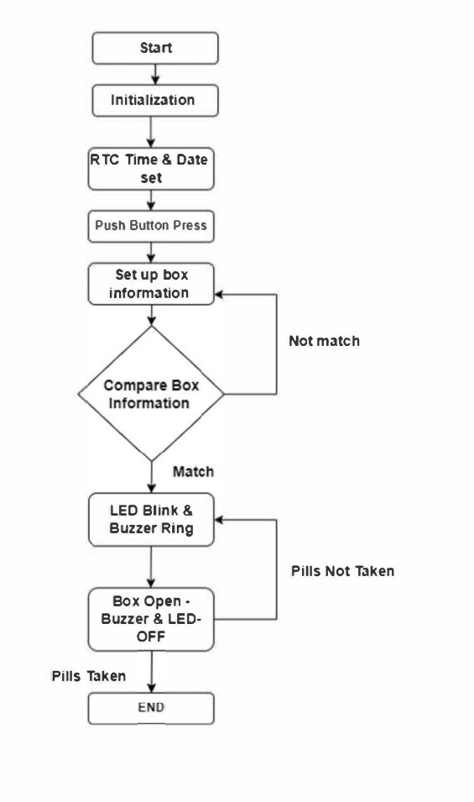

**5.2 Solution and Technical architecture**

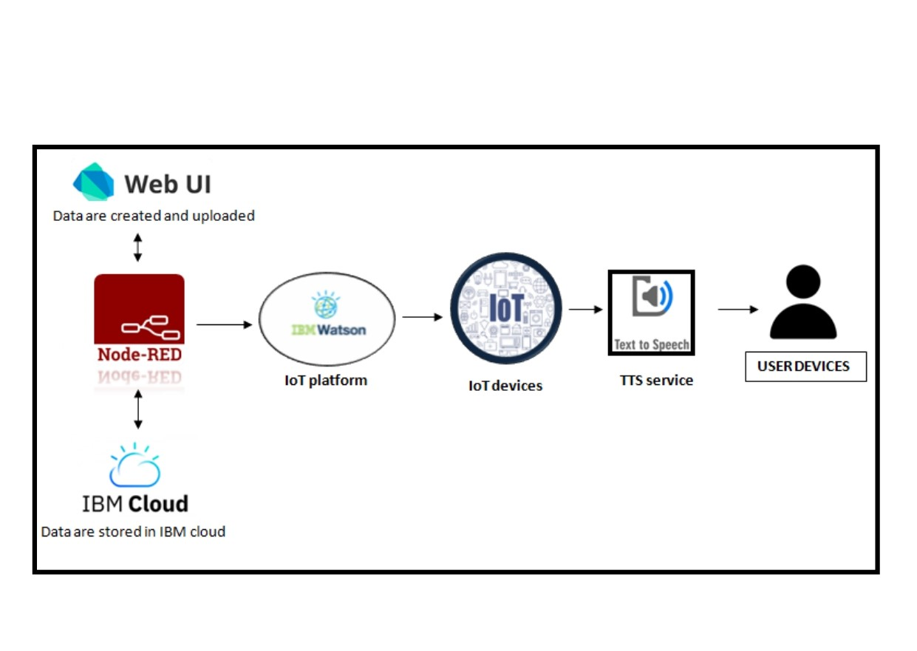

**5.3 User stories**

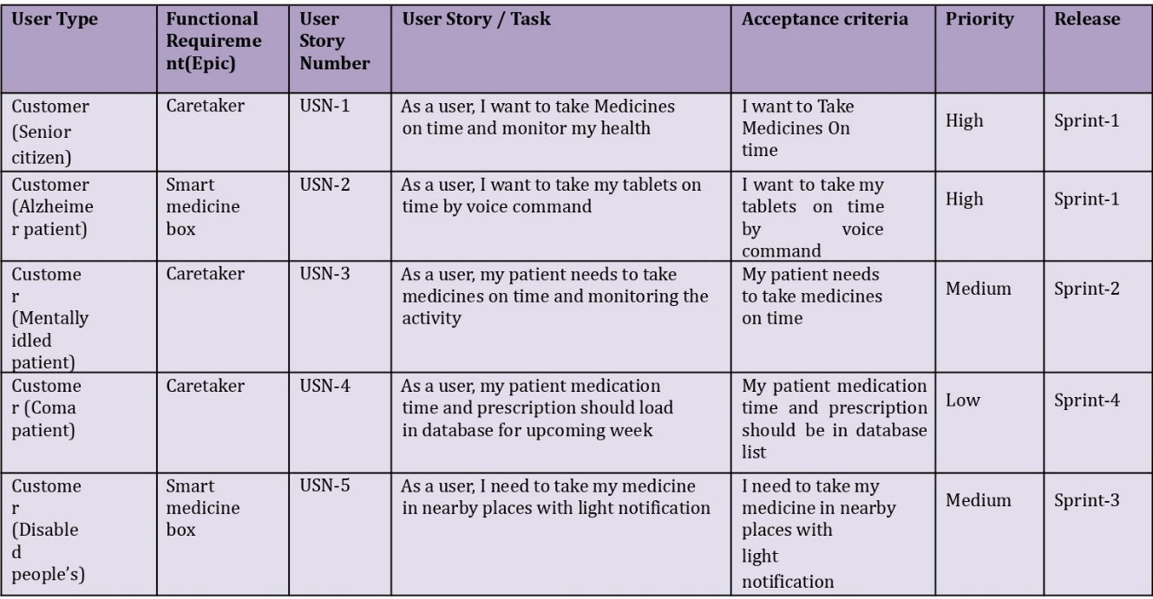

# CHAPTER 6

**6.PROJECT PLANNING & SCHEDULING**

**6.1Milestone and Activity list**

|  |  |
| --- | --- |
| Date | 04 November 2022 |
| Team ID | PNT2022TMID10261 |
| Project Name | Personal assistance for seniors who are self- reliant |

|  |  |  |
| --- | --- | --- |
| **TITLE** | **DESCRIPTION** | **DATE** |
| **Literature Survey & Information Gathering** | Gathering information by refering technical papers research publications which describes literature survey. | 10 october 2022 |
| **Prepare Empathy Map** | To establish users pain and gain prepare the empathy map canvas on problem statement. | 11 october 2022 |
| **Ideation** | Establishing brainstorm sessions and emphasize the top ideas based on the importance of scalability and feasibility. | 13 october 2022 |
| **Proposed Solution** | Prepare the proposed solution which describes idea,uniqueness,customer satisfaction,business model and scalability of solution. | 14 october 2022 |
| **Problem Solution Fit** | Prepare problem solution fit which describes the existence of problem. | 17 october 2022 |
| **Solution Architecture** | Defining process of developing solution based on predefined processes. | 18 october 2022 |
| **Customer Journey** | Prepare a customer journey map which understand the customers on users interaction and experiences from scratch to finding solution. | 20 october 2022 |
| **Functional Requirement** | Prepare the functional requirement document which specifies the requirements. | 21 october 2022 |
| **Data Flow Diagrams** | Draw the data flow diagrams based on problem statement. | 22 october 2022 |
| **Technology Architecture** | Prepare a technology architecture diagram which describes the working. | 24 october 2022 |
| **Prepare Milestone & Activity List** | Prepare the milestone and activity list of the project. | 28 october 2022 |
| **Project Development - Delivery of Sprint-1, 2, 3 & 4** | Develop and submit the developed code by implementing and testing it. | In progress |

|  |
| --- |
|  |

**6.2 Sprint Development Plan**

|  |  |
| --- | --- |
| Date | 04 October 2022 |
| Team ID | PNT2022TMID10261 |
| Project Name | Project - Personal Assistance for Seniors who are Self- Reliant |
| Maximum Marks | 8 Marks |

**Product Backlog, Sprint Schedule, and Estimation (4 Marks)**

|  |  |  |  |  |  |  |
| --- | --- | --- | --- | --- | --- | --- |
| **Sprint** | **Functional**  **Requirement (Epic)** | **User Story**  **Number** | **User Story / Task** | **Story Points** | **Priority** | **Team**  **Members** |
| Sprint-1 | Registration | USN-1 | As a user, I can register for the application by entering my email or mobile number, password, and confirming my password. | 2 | High | Jayaram  Akash  Arunagiri  Afsal |
| Sprint-1 |  | USN-2 | As a user, I will receive confirmation email once  I have registered for the application | 1 | High | Jayaram  Akash  Arunagiri  Afsal |
| Sprint-1 |  | USN-3 | As a user, I can register for the application through Gmail | 2 | medium | Jayaram  Akash  Arunagiri  Afsal |
| Sprint-1 |  | USN-4 | As a user, I can log into the application by entering email or mobile number & password | 2 | High | Jayaram  Akash  Arunagiri  Afsal |
| Sprint-2 | Login | USN-5 | As a user, I can update my reminders and medicines wherever required | 1 | High | Jayaram  Akash  Arunagiri  Afsal |
| Sprint-2 | Dashboard | USN-6 | As a user, I can check the application whether the medicine dosage is completed | 1 | Medium | Jayaram  Akash  Arunagiri  Afsal |
|  |  | USN-7 | For any troubleshooting, the user can send a mail to the technical team | 1 | Low | Jayaram  Akash  Arunagiri  Afsal |
| Sprint-3 |  | USN-8 | Ensures smooth functioning and data warehousing strategies | 1 | Medium | Jayaram  Akash  Arunagiri  Afsal |

**Project Tracker, Velocity & Burndown Chart: (4 Marks)**

|  |  |  |  |  |  |  |
| --- | --- | --- | --- | --- | --- | --- |
| **Sprint** | **Total Story Points** | **Duration** | **Sprint Start Date** | **Sprint End Date (Planned)** | **Story Points**  **Completed (as on**  **Planned End Date)** | **Sprint Release Date (Actual)** |
| Sprint-1 | 20 | 10 Days | 24 Oct 2022 | 03 Nov 2022 | 20 | 03 Nov 2022 |
| Sprint-2 | 20 | 5 Days | 4 Nov 2022 | 09 Nov 2022 | 20 | 09 Nov 2022 |
| Sprint-3 | 20 | 5 Days | 10 Nov 2022 | 15 Nov 2022 | 20 | 15 Nov 2022 |
| Sprint-4 | 20 | 2 Days | 16 Nov 2022 | 17 Nov 2022 | 20 | 17 Nov 2022 |

**Velocity:**

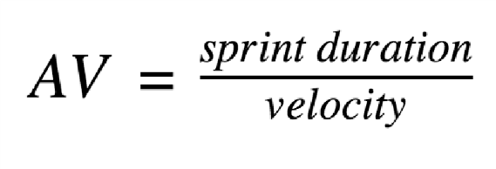

For Sprint-1, AV=20/10=2

For Sprint-2, AV=20/5=4

For Sprint-3, AV=20/5=4

For Sprint-4, AV=20/2=10

**Burndown Chart:**

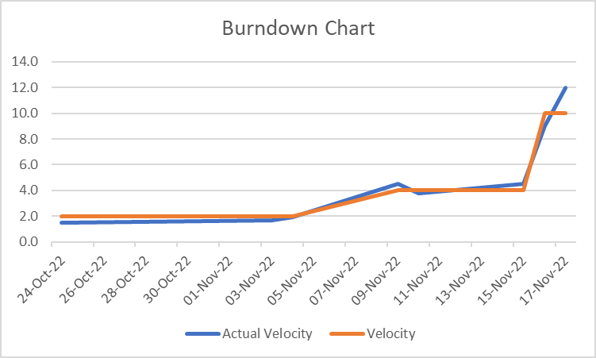

# 

# CHAPTER 7

## CODING & SOLUTIONING

**7.1 Feature 1**

In the feasibility study, not all of reminders were effective for patients to take their medication in case they were away from the smartphone or they did not notice the small sound of reminders. We would design and improve reminders to repeat second or third time in user’s favorite interval, to display some messages about reminders on the smartphone until the patient inputs records of medication-taking, or to send a reminder to their home phone.If someone else is taking an active part in helping to manage user’s medications, then they prefer an app with a number of collaboration features. MyTherapy measures and stores vitals, keeps medication usage history with the ability to print personal health report and share results with a doctor or family members.Care Zone uses the camera to take pictures of important documents and save them. The app helps to organize key contacts including doctors, pharmacies, insurance, and family members to safely share access to coordinate care.

**7.2 Feature 2**

One of the wonders of modern medicine are the wide variety of medications that enhance both the quality and length of our lives. Today medicine is used to control blood pressure, insulin, cholesterol and even the rate at which our hearts beat. Yet medicines are both a godsend and a curse. If prescribed and managed properly they work. If not, then they are not effective and can even result in hospitalization or death. This is why having a medication reminder system that works is very important to your health. It is also important to “brown bag” your medications from time to time as part of good medication management practices. Medication reminder systems must include more than a nudge to take the medication at the right time. They must also include knowledge of how you need to take the medication. Does it need to be taken with food or on an empty stomach? Do you need to avoid certain foods or drinks while taking it? For instance, many medications require that you avoid drinking grapefruit juice. Other medication may require you to abstain from drinking alcohol. Some work better if you take them before you go to bed, and so on. Your medication reminder system must include this information. If you are taking fewer than six medications daily, you may be able to commit information on how to take your medication to memory, such as remembering to take Metformin with every meal. However, no matter how many medications you take nearly everyone can benefit from a medication reminder system.

# CHAPTER 8

## TESTING

**8.1 TEST CASES**

Software testing follows a common process. Tasks or steps include defining the test environment, developing test cases, writing scripts, analyzing test results and submitting defect reports. Testing can be time-consuming. Manual testing or ad-hoc testing may be enough for small builds. However, for larger systems, tools are frequently used to automate tasks. Automated testing helps teams implement different scenarios, test differentiators (such as moving components into a cloud environment), and quickly get feedback on what works and what doesn’t. A good testing approach encompasses the application programming interface (API), user interface and system levels. As well, the more tests that are automated, and run early, the better. Some teams build in-house test automation tools

A test case is a defined format for software testing required to check if a particular application/software is working or not. A test case consists of a certain set of conditions that need to be checked to test an application or software i.e. in more simple terms when conditions are checked it checks if the resultant output meets with the expected output or not. A test case consists of various parameters such as Id, condition, steps, input, expected result, result, status, and remarks.

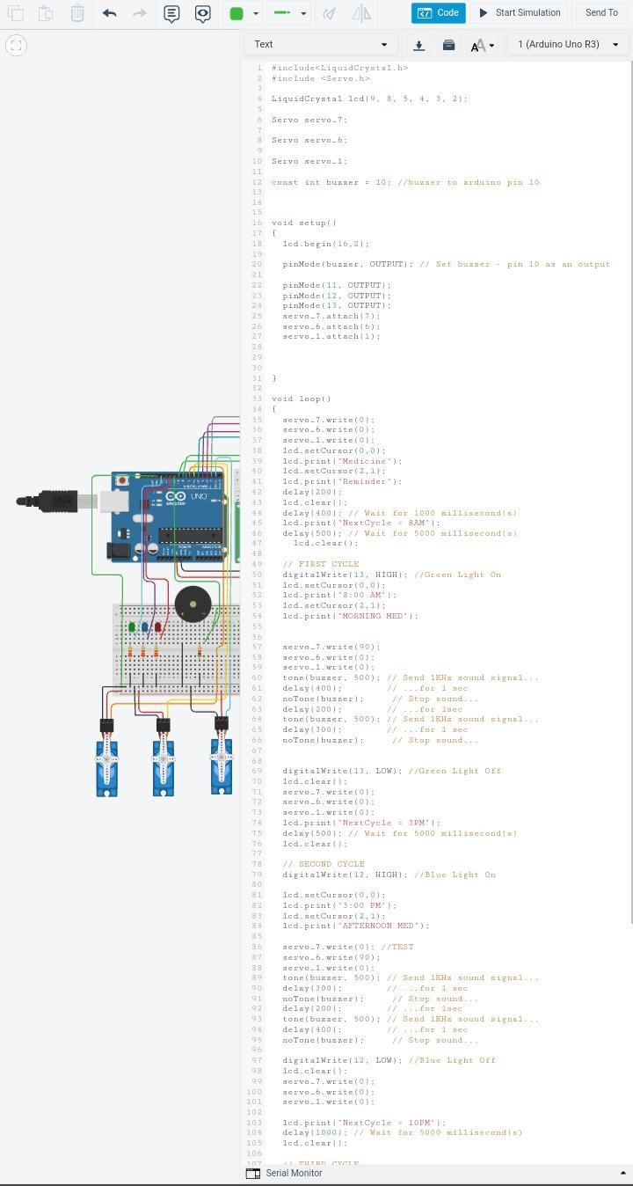

**8.2 User Acceptance Testing**

once software has undergone Unit, Integration and System testing because developers might have built software based on requirements document by their own understanding and further required changes during development may not be effectively communicated to them, so for testing whether the final product is accepted by client/end-user, user acceptance testing is needed.

* + Developers code software based on requirements document which is their “own” understanding of the requirements and **may not actually be what the client needs from the software**.
  + Requirements changes during the course of the project may not be communicated effectively to the developers

User Acceptance Testing (UAT), which is performed on most UIT projects, sometimes called beta testing or end-user testing, is a phase of software development in which the software is tested in the "real world" by the intended audience or business representative.

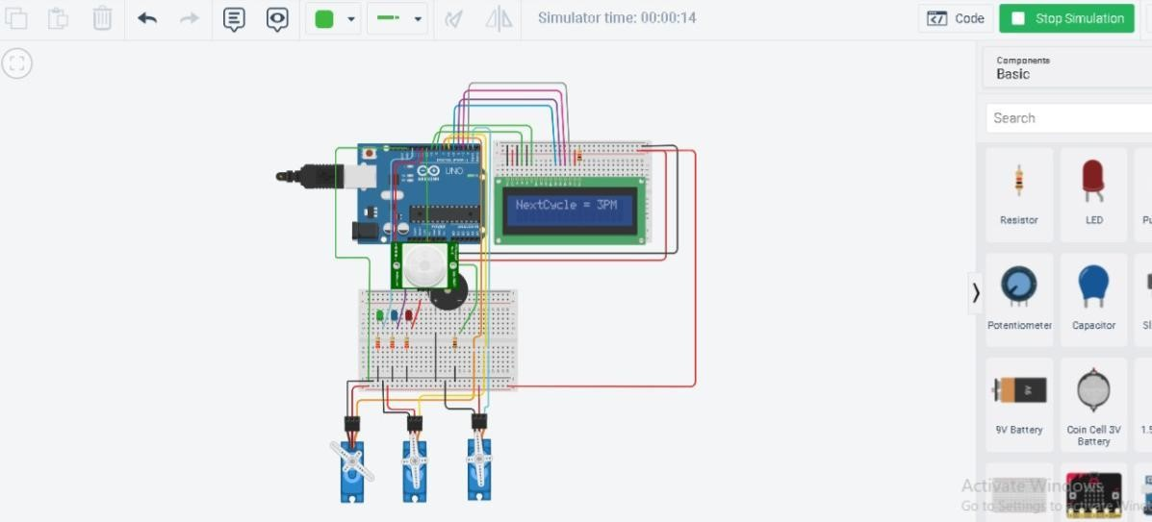

# 

# CHAPTER 9

## RESULT

**9.1 Performance Metrics**

Performance metrics are data used to track processes within a business. This is achieved using activities, employee behavior, and productivity as key metrics. These metrics are then used by employers to evaluate performance. This is in relation to an established goal such as employee productivity or sales objectives

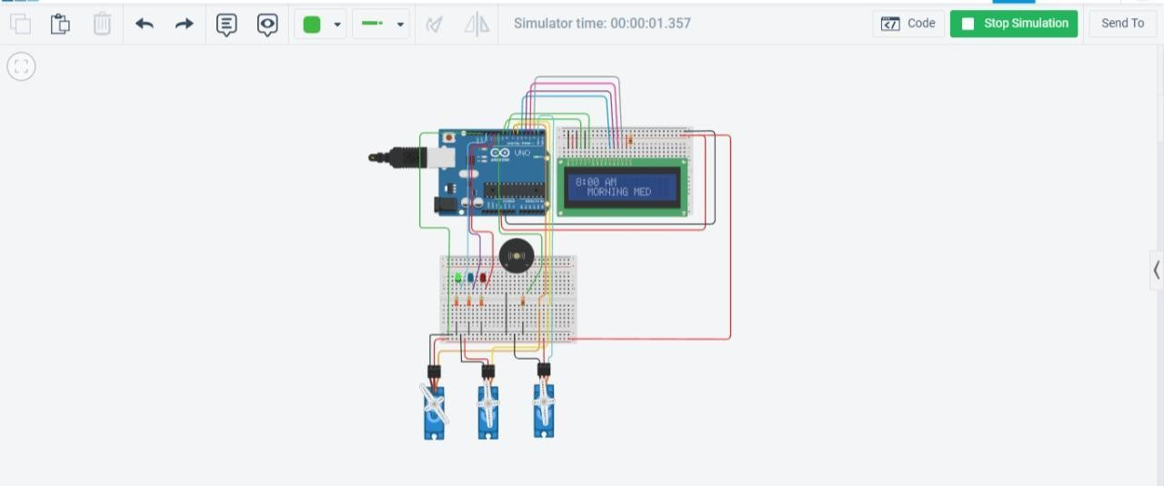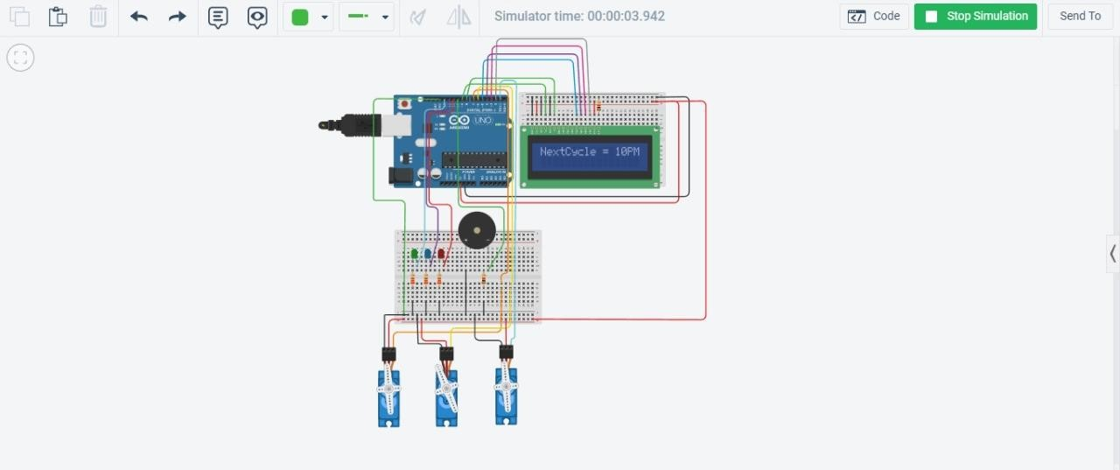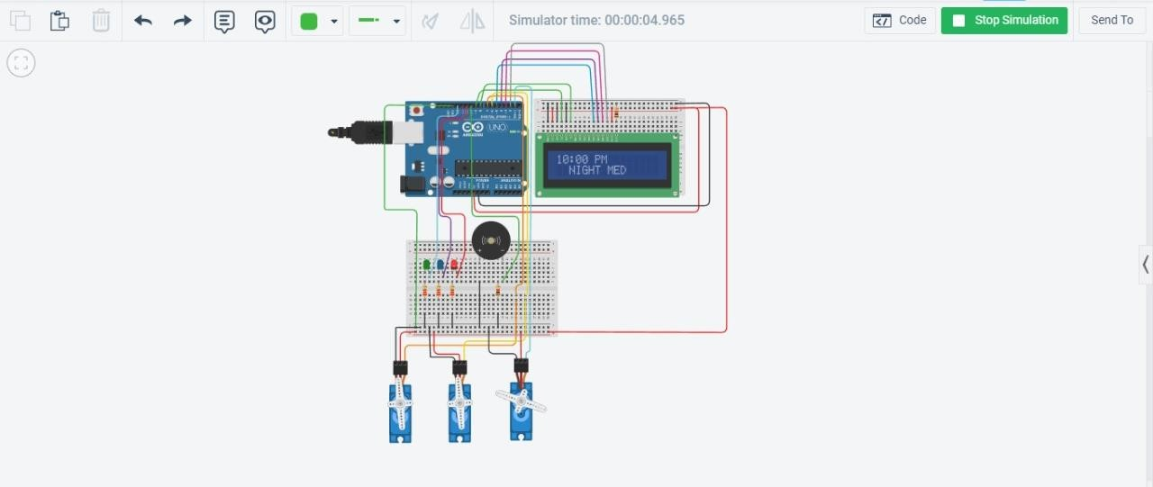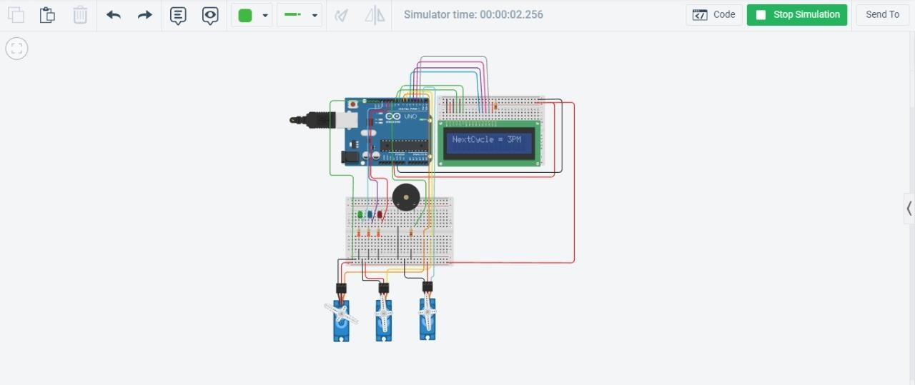

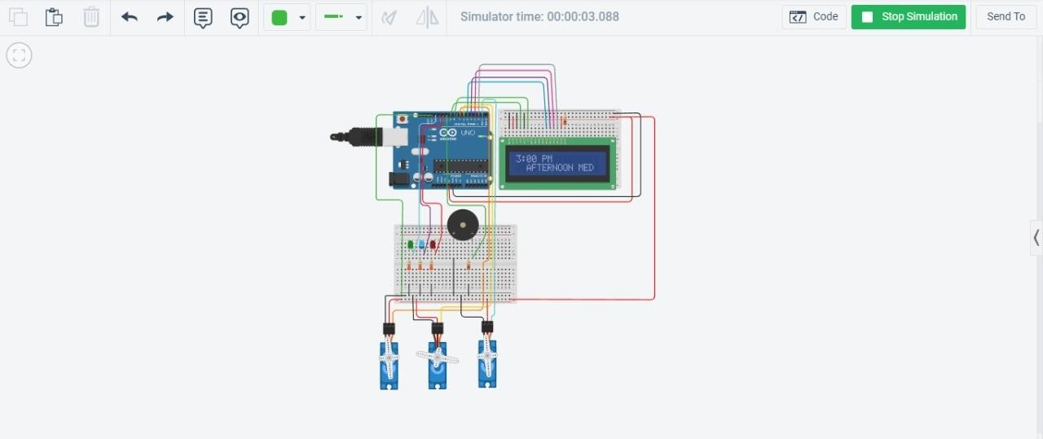

## 

## 

# CHAPTER 10

## ADVANTAGES & DISADVANTAGES

**ADVANTAGES**

* medication reminder and organizer can help to prevent these life-threatening mistakes. They remind your loved one to take the right medication at the right time. Medication reminders are an important piece of any aging in place plan
* Reminds Your Senior to Take Their Medication
* Prevent Errors
* Easy to Use
* Be Proactive

**DISADVANTAGES**

* Cost Efficient
* Power supply problems
* Circuit Cost High
* Maintenance Cost High

# 

# 

# CHAPTER 11

**CONCLUSION**

The idea that one can rely on his or her own judgment, choices, and be free from these societal influences is to be self-reliant. As such, according to Transcendentalism and Emerson, **it's better to trust yourself**. In some cases, if not most or all cases, to trust yourself over and above what others believe.

Hence an attempt was made to build a medicine reminder kit which gives indication at proper time and also an alert to pre-guardian about tablet consumption status. Medicine reminder apps and devices which are a part of IoT,

# CHAPTER 12

# The project can be further developed by bringing into the feature of informing the medicine name during the notification. The voice assistance which is given can be customized by adding the user's voice or the caretaker’s voice. Further the mobile application can update medicines by taking voice commands as an input from the user.

# CHAPTER 13

## APPENDIX

**Source Code**

**#include<LiquidCrystal.h>**

**#include <Servo.h>**

**LiquidCrystal lcd(9, 8, 5, 4, 3, 2);**

**Servo servo_7;**

**Servo servo_6; Servo servo_1; const int buzzer = 10; //buzzer to arduino pin 10**

**void setup()**

**{ lcd.begin(16,2); pinMode(buzzer, OUTPUT); // Set buzzer - pin 10 as an output pinMode(11, OUTPUT);**

**pinMode(12, OUTPUT); pinMode(13, OUTPUT);**

**servo_7.attach(7); servo_6.attach(6); servo_1.attach(1);**

**} void loop()**

**{**

**servo_7.write(0); servo_6.write(0); servo_1.write(0); lcd.setCursor(0,0); lcd.print("Medicine"); lcd.setCursor(2,1); lcd.print("Reminder"); delay(200); lcd.clear(); delay(400); // lcd.print("NextCycle = 8AM"); delay(500); // Wait for 500 millisecond(s) lcd.clear();**

**// FIRST CYCLE digitalWrite(13, HIGH); //Green Light On lcd.setCursor(0,0); lcd.print("8:00 AM"); lcd.setCursor(2,1);**

**lcd.print("MORNING MED");**

**servo_7.write(90); servo_6.write(0); servo_1.write(0); tone(buzzer, 500); // Send 1KHz sound signal...**

**delay(400); noTone(buzzer); // Stop sound...**

**delay(200); tone(buzzer, 500); // Send 1KHz sound signal...**

**delay(300); noTone(buzzer); // Stop sound...**

**digitalWrite(13, LOW); //Green Light Off lcd.clear();**

**servo_7.write(0); servo_6.write(0); servo_1.write(0); lcd.print("NextCycle = 3PM"); delay(500); // Wait for 500 millisecond(s) lcd.clear();**

**// SECOND CYCLE**

**digitalWrite(12, HIGH); //Blue Light On lcd.setCursor(0,0); lcd.print("3:00 PM"); lcd.setCursor(2,1);**

**lcd.print("AFTERNOON MED");**

**servo_7.write(0); //TEST**

**servo_6.write(90); servo_1.write(0); tone(buzzer, 500); // Send 1KHz sound signal...**

**delay(300); noTone(buzzer); // Stop sound... delay(200); tone(buzzer, 500); // Send 1KHz sound signal...**

**delay(400); noTone(buzzer); // Stop sound...**

**digitalWrite(12, LOW); //Blue Light Off lcd.clear(); servo_7.write(0); servo_6.write(0); servo_1.write(0);**

**lcd.print("NextCycle = 10PM"); delay(1000); lcd.clear();**

**// THIRD CYCLE digitalWrite(11, HIGH); //Red Light On**

**lcd.setCursor(0,0); lcd.print("10:00 PM"); lcd.setCursor(2,1); lcd.print("NIGHT MED");**

**servo_7.write(0); //TEST**

**servo_6.write(0); servo_1.write(90); tone(buzzer, 500); // Send 1KHz sound signal...**

**//delay(1000); // noTone(buzzer); // Stop sound...**

**delay(200); // tone(buzzer, 500); // Send 1KHz sound signal..**

**delay(300); noTone(buzzer); // Stop sound...**

**digitalWrite(11, LOW); //Red Light Off lcd.clear(); servo_7.write(0); servo_6.write(0); servo_1.write(0);**

**delay(200);**

**}**

**GITHUB LINK :** <https://github.com/IBM-EPBL/IBM-Project-13051-1659508657>

**DEMO LINK** : <https://youtu.be/4pttWrxCh2U>